ME331 Advanced Thermo

September 19, 2018

Min Joon So

1. **Draw conclusions from your results.**

There are many measures that can be used to identify performances of different engines. I first used efficiency (eta) to easily understand work_out compared to Qin.

First I tried to ignore any side effects of having too high compression ratio and high AFR, such as knocking, to clearly see correlationship between efficiency and variables . Varying the compression ratio from 5 to 25 and AFR from 10 to 18, calculations yield the following graphs and results (few omitted here but included in the appendix):

Diesel: eff_max = 63.5 %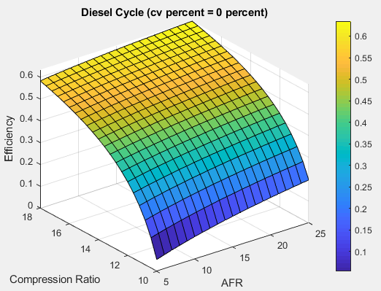

Dual (40%): eff_max = 70 %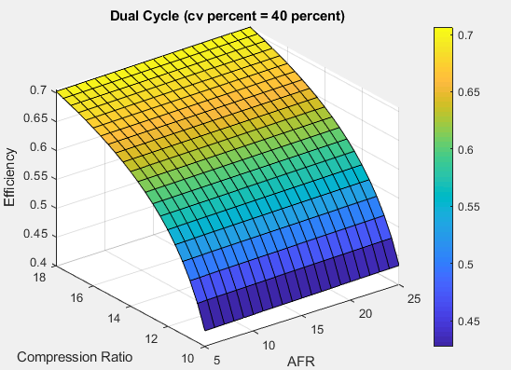

Otto: eff_max = 72.5 %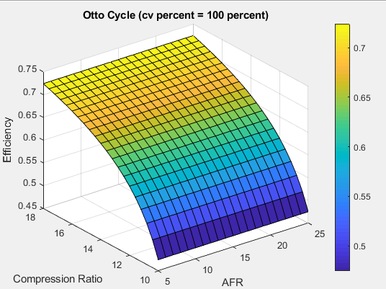

The graph of Otto cycle clearly reveals how AFR has none or negligible influence on the efficiency. In fact, dual cycle (with Qin@cv 40 %) also shows small influence of AFR, although greater than in Otto cycle. Diesel cycle, however, clearly shows AFR has significant influence on the efficiency.

Given the same compression ratio and heat addition, Otto cycle yielded the highest efficiency of 72 %, compared to 63 % of diesel cycle. Dual cycles show linearly increasing trend in efficiency when increasing Qin@cv percentage. Form the result, it is reasonable to make a conjecture that: (1) AFR has greater positive influence on the efficiency as Qin@cv percentage increases, (2) greater the compression ratio, higher the efficiency, and (3) greater the Qin@cv percentage, higher the efficiency. However, these conclusions are made based on comparing each cycle with the same range of compression ratio.

Gasoline engines the compression ratio has its own limits. The compression ratio of a gasoline-powered engine will usually not be much higher than 10:1 due to potential engine knocking (autoignition). The unburned mixture may auto-ignite by detonating from pressure and heat alone, rather than ignite from the spark plug at exactly the right time.

Higher compression ratios can be achieved in diesel engines because they do not compress the fuel, but rather compress only air and then inject fuel into the air which was heated by compression. Compression ratios in the range of 12 to 20 are typical for diesel engines. The higher compression ratio (greater expansion) and the higher peak temperature causes that diesel engines reach higher thermal efficiency.

Taking this limit into account, re-calculation was done to find efficiencies for all the cycles. I varied compression ratio of Otto cycle up from 5 to 13 and 10 to 25 for diesel cycle. The result was: eff of Otto cycle: 62.99% vs. Diesel: 63.47%. Now diesel has better thermal efficiency than Otto cycle.

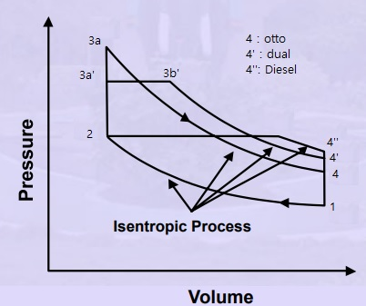

1. **Formulate an executive summary intended for your company's engineering management team that describes your research; develop logical arguments supporting your conclusions regarding your recommendations on how your company should be designing engines with regard to these 3 parameters.**

My research is on engine output performance with respect to varying: AFR, Qin@cv, and compression ratio. The diesel cycle is less efficient than the Otto cycle when using the same compression ratio, as you can see in the explanation from Q1. However, practical diesel engines are known to be 30% - 35% more efficient than gasoline engines because since the fuel is not introduced to the combustion chamber in diesel engines until it is required for ignition, the compression ratio is not limited by the need to avoid knocking, so higher ratios are used than in spark ignition engines. The compression ratio of a gasoline-powered engine will usually not be much higher than 10:1 due to potential engine knocking while the range of 12 to 20 are typical for diesel engines. The engine knocking can be reduced by using high-octane fuel, which increases the gasoline’s resistance to autoignition. The higher the octane number, the more compression the fuel can withstand before detonating.

Proper AFR calibration is critical to performance and durability of the engine and its components. The AFR defines the ratio of the amount of air consumed by the engine compared to the amount of fuel. For gasoline engines, the stoichiometric, A/F ratio is 14.7:1, which means 14.7 parts of air to one part of fuel. The turbocharger increases the density of the air resulting in a denser mixture. The denser mixture raises the peak cylinder pressure, therefore increasing the probability of knock. As the AFR is leaned out, the temperature of the burning gases increases, which also increases the probability of knock. This is why it is imperative to run richer AFR on a boosted engine at full load. Doing so will reduce the likelihood of knock, and will also keep temperatures under control.

As a transportation fuel, diesel fuel offers a wide range of performance, efficiency, and safety features. Diesel fuel also has a greater energy density than other liquid fuels, so it provides more useful energy per unit of volume. Diesel fuel in tanks and trucks because diesel fuel is less flammable and less explosive than other fuels. Taking these advantages in account, diesel engine can be used for vehicles that require greater safety and efficiency.

Adjusting Qin@cv percentage allows to take advantage of good characteristics of diesel and Otto engines. The dual combustion cycle allows heat to be added partly at constant volume and partly at constant pressure, which means more time is available for the fuel to completely combust. An ideal dual cycle has a compression ratio of 14 and cutoff ratio of 1.2.

1. **Perform background research (a brief literature review) that reflects your understanding of current trends in piston-engine design.**

*The Future of the Car, Oliver S Kaiser, Heinz Eickenbusch, Vera Grimm, Axel Zweck* (<https://www.vditz.de/fileadmin/media/publications/pdf/Band_75_eng.pdf>)

This article talks about ‘Diesotto’, a petrol engine that combines the benefits of the low-emission petrol (Otto) engine with the fuel economy of diesel, especially of injection systems. (Some of the sentences here are directly quoted from the article.) The paper describes that the performance of petrol engines has been enhanced by direct injection systems, such as the one first fitted in 2000 by VW to their Lupo FSI. They provide payback in the form of reduced fuel consumption on low throttle. Electromagnetically controlled fuel injectors have so far played a major role here. Combustion takes place either in the classic stoichiometric proportion – i.e. precisely the right quantity of air to burn the injected fuel – or in a lean burn process with surplus air so that all the fuel is burnt without residue. In the part-load operational range, lean burn allows increased efficiency with a corresponding reduction in fuel consumption, especially under routine operating conditions.

Attention is now shifting towards spray-guided systems using ultra-fine atomization, which, however, requires high pressures of around 200 bar. However, this is based on complex and costly piezo technology.

Direct injection is state-of-the-art with diesel engines: high injection pressures with correspondingly fine atomization make for an efficient engine operating on lean burn – except when it is at full throttle. Here we are seeing a switch from pump-jet technology to ‘common rail’. Whereas with common-rail injection the feedline shared by all the cylinders is at a pressure of around 1500 bar, with pump-jet technology it is only the jet for each cylinder which raises it above 2000 bar. A disadvantage of pump-jet injection is that it is mechanically driven by the camshaft. This means that the injection intervals are fixed, resulting in less efficient operation at low speeds and reduced throttle.

One further advance with the petrol engine has been the GCI (Gasoline Compression Ignition) process. According to the article, this involves the addition of up to 80% exhaust gases to the air intake. The mixture ignites throughout the whole combustion chamber simultaneously once the level of compression necessary for selfignition has been reached. The high exhaust gas content acts as a brake on the explosive process and thus avoids the generation of nitrogen oxides. With this totally camshaft-free engine, it is possible to shut down cylinders temporarily and to hold them in reserve for bursts of full throttle. The Diesotto provides adequate torque from low fuel consumption and is not as expensive to manufacture as a diesel engine. Volkswagen are additionally optimising their ‘Combined Combustion System’ to operate on synthetic fuels.

**Appendix**

Thermo_hw1_v2.m (main)

close all; clear all; clc;

%% Variables

r = linspace(5,25,21);

AFR = linspace(10,18,21);

cv_percent = linspace(0,100,11);

result= zeros(length(r),length(AFR),length(cv_percent));

for i = 1:length(r)

for j = 1:length(AFR)

for k = 1:length(cv_percent)

%r, AFR, cv_percent provided, 'cycle' function calculates and returns efficiency

[result(i,j,k)]=cycle(r(i),AFR(j),cv_percent(k));

end

end

end

[X, Y] = meshgrid(r,AFR);

%% Graphs efficiency

[max_0, r_max_0, AFR_max_0] = display_graph(X,Y,result,2,0); %Diesel Cycle (0%)

[max_20, r_max_20, AFR_max_20] = display_graph(X,Y,result,3,20); %Dual Cycle 20%

[max_40, r_max_40, AFR_max_40] = display_graph(X,Y,result,4,40); %Dual Cycle 40%

[max_60, r_max_60, AFR_max_60] = display_graph(X,Y,result,5,60); %Dual Cycle 60%

[max_80, r_max_80, AFR_max_80] = display_graph(X,Y,result,6,80); %Dual Cycle 80%

[max_100, r_max_100, AFR_max_100] = display_graph(X,Y,result,1,100); %Otto Cycle (100%)

Cycle.m

function [eta]= cycle(r,AFR, cv_percent)

Q_LHV = 42.5e6; %J/KG

Cp = 1.01e3; %J/(kg*K)

rho_a = 1.225; %kg/m^3

gamma = 1.4;

Cv = Cp/gamma;

%% State 1

P1 = 101.3e3; %Pa

V1 = 1/1000; %m^3

T1 = 300; %K

adb_const = P1*V1^gamma;

%% State 2

V2 = V1/r;

P2 = adb_const / V2^gamma;

T2 = T1*(r^(gamma-1));

%% State 3a

Qin1_overMa = cv_percent/100 /AFR *Q_LHV;

T3a = Qin1_overMa/Cv+T2;

P3a = P2/T2*T3a;

V3a = V2;

%% State 3b

Qin2_overMa = (100-cv_percent)/100 /AFR *Q_LHV;

T3b = Qin2_overMa/Cp+T3a;

V3b = V3a/T3a*T3b;

%% Efficiency Equation

alpha = P3a/P2;

beta = V3b/V3a;

eta = 1-(1/(r^(gamma-1))*(alpha*beta^gamma -1)/(alpha*gamma*(beta-1)+(alpha-1)));

m_f= V1*4*rho_a/AFR; %kg

w = m_f * Q_LHV * eta;

end

display_graph.m

function [C,I1,I2]= display_graph(X,Y,result,n,percent)

figure(n)

surf(X,Y,result(:,:,percent/10+1))

colorbar

xlabel('AFR')

ylabel('Compression Ratio')

zlabel('Efficiency')

if percent == 100

title(sprintf('Otto Cycle (cv percent = %i percent)',percent))

temp = result(1:8,:,percent/10+1); % limit compression ratio upto 13 if Otto

elseif percent == 0

title(sprintf('Diesel Cycle (cv percent = %i percent)',percent))

temp = result(6:end,:,percent/10+1);

else

title(sprintf('Dual Cycle (cv percent = %i percent)',percent))

temp = result(:,:,percent/10+1);

end

[C,I] = max(temp(:));

[I1,I2,I3] = ind2sub(size(result),I);

% text(I1,I2,I3,'some text to display');

end

